Cloned the repository. Used the README to get it up and running. When running I can go to this:
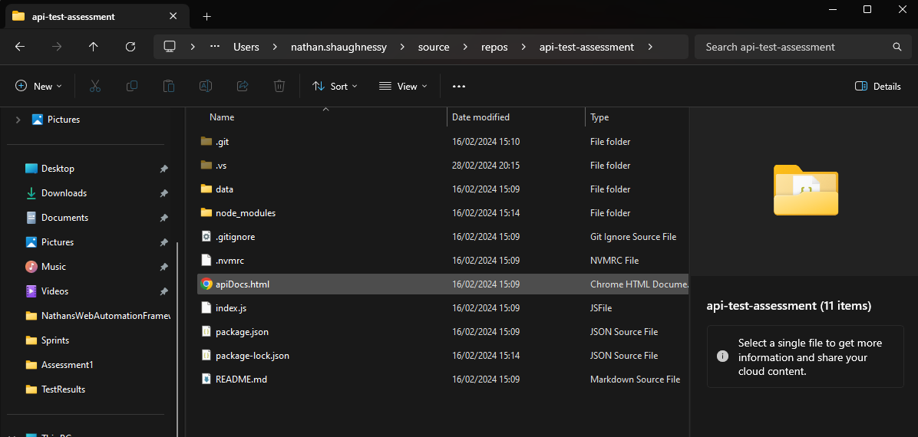
To see all this info:
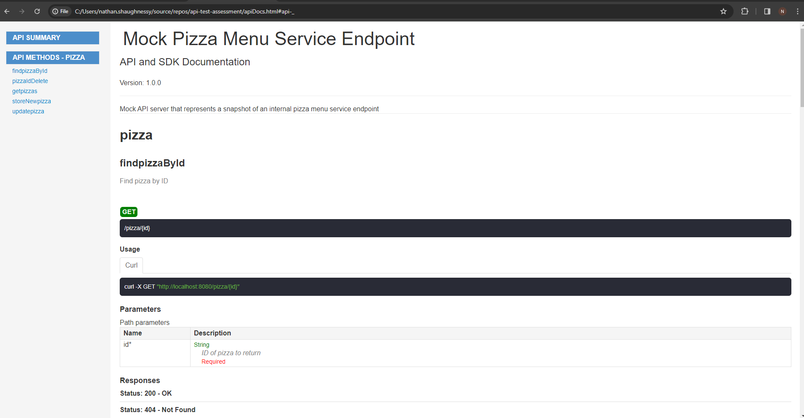
Added Test File and ran first Test:
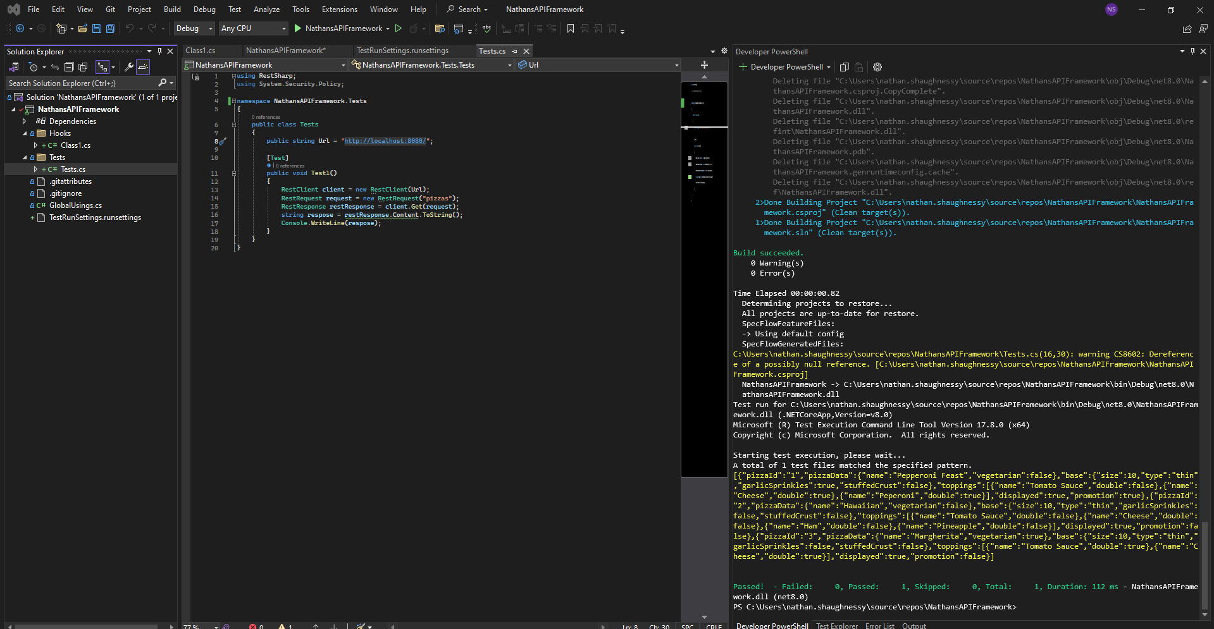
Played around in Postman to retrieve all the pizzas etc.
Added TestRunSettings.runsettings file:
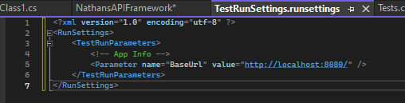
Added this to csproj:
Watched this video: RestSharp: REST APIs Testing using C# RestSharp and Json.Net - Part 1 | Getting started (youtube.com)
Added Pizza Properties in PizzaDetails Class.
Added nuget packages earlier, restshapr and newton soft, specflow as well maybe use later date
Created AllPizzas class and now got get pizzas methods
Create Objects of the classes I’ve created earlier and call them in the tests folder by creating the objects in the test class created and call the methods created.
Created test class. Created VerifyListOfPizzas test.
Arrange: Create instance of Methods class from Assembly.pizzas, class contains methods to interact with API, retrieving the pizzas.
Act: Here I invoke GetPizzas method, from methods object created in previous step. Method is responsible for making a request to the API endpoint to retrieve the list of pizzas. The response variable will hold the result returned by this method. Which is expected to be a collection of pizza objects.
Assert: ‘Assert.That(response, Is.Not.Null, "Response should not be null");: This assertion verifies that the response object is not null. If it is null, it indicates that there was an issue fetching the pizzas from the API.
Assert.That(response.Count, Is.EqualTo(3), "There should be 3 pizzas in the response");: This assertion checks if the count of pizzas in the response collection is exactly 3. If it's not, it indicates that the API didn't return the expected number of pizzas.
foreach (var pizza in response) { ... }: This loop iterates over each pizza object in the response collection.
Assert.That(pizza.pizzaId, Is.Not.Null.Or.Empty, "Each pizza should have a non-null and non-empty pizzaId");: Inside the loop, this assertion checks that each pizza object has a non-null and non-empty pizzaId. If any pizza object fails this assertion, it means that the pizzaId is missing or empty.
Console.WriteLine($"Pizza Id: {pizza.pizzaId}");: This line outputs the pizzaId of each pizza object to the console.
Overall, this test method verifies that the API endpoint responsible for retrieving pizzas returns a valid response with the expected structure and content. It checks for the presence of the response object, ensures that it contains the correct number of pizza objects, and validates that each pizza object has a non-null and non-empty pizzaId. If any of these conditions fail, the test will indicate that there's an issue with the API response.
GO BACK AND REDO POST PIZZA TO THE ONE USED BEFORE – THE PAYLOAD WAY THEN DO A GET REQUEST
GetPizzas():
- Ensures that the base URL is initialized.
- Creates a RestClient object and a RestRequest object with the appropriate endpoint and HTTP method.
- Adds headers and sets the request format to JSON.
- Executes the request and retrieves the response.
- Extracts the content from the response.
- Deserializes the JSON content into a list of PizzaDetails objects.
- Returns the list of pizzas.
Simple terms:
- Ensure the base URL is ready: Before doing anything, make sure we have the main address where our API lives.
- Prepare to talk to the API: Imagine we're getting ready to make a phone call to the pizza place. We need their number (base URL) and know what we want to say (the request we're going to make).
- Set up our request: Write down what we want to ask for (in this case, we're asking for a list of pizzas). We also tell them that we prefer to get our information in a certain format (like asking for the menu in English instead of French).
- Make the call: Actually call the pizza place and ask for the menu.
- Listen to the response: They'll give us the menu over the phone. We write down everything they say.
- Understand the menu: We look at the menu and understand what each pizza is.
- Write down the pizzas: We list out all the pizzas they mentioned on the menu.
- Give the list to whoever asked: We pass the list of pizzas to whoever requested it. They can now see what pizzas are available.
So, the method "GetPizzas" is like making a phone call to the pizza place (the API), asking for their menu (list of pizzas), and then writing down all the pizzas they offer and sharing it with others who want to know.
Simpler terms:
- Ensure the base URL is ready: Before doing anything, the method checks if the base URL is set up properly. This is like making sure we have the correct phone number for the pizza place.
- Prepare to talk to the API: Once we have the base URL, we create a RestClient object, which is like preparing to make a phone call to the pizza place.
- Set up our request: We create a RestRequest object and specify that we want to make a GET request to the "pizzas" endpoint. This is like deciding what we want to ask for when we call the pizza place, such as requesting their menu.
- Make the call: We use the RestClient to execute the RestRequest, which sends the request to the API and gets the response. This is like making the actual phone call to the pizza place and listening to what they have to say.
- Listen to the response: The API responds with information about the pizzas available, which we store in a RestResponse object. This is like listening to the pizza place's response over the phone.
- Understand the menu: We extract the content of the response, which contains information about the pizzas, and store it in a variable called "content". This is like writing down the menu items that the pizza place told us.
- Write down the pizzas: We deserialize the content of the response into a list of PizzaDetails objects using JsonConvert.DeserializeObject. This is like organizing the information we received from the pizza place into a list of pizzas.
- Give the list to whoever asked: Finally, we return the list of pizzas to whoever called the GetPizzas method. This is like sharing the list of pizzas with someone who wanted to know what pizzas are available.
So, the method "GetPizzas" essentially acts as a bridge between our code and the API, allowing us to retrieve information about available pizzas and use it within our application.
```// Add headers to the request to specify that it accepts JSON data
restRequest.AddHeader("Accept", "application/json");

// Set the request format to JSON
restRequest.RequestFormat = DataFormat.Json;
Yes, those bits are essential for communicating with the API effectively. Let me break down their importance:
Adding headers: The line restRequest.AddHeader("Accept", "application/json"); specifies that the client is asking the server to respond with JSON-formatted data. This is important because it tells the server how the client expects to receive the data. It's like telling the pizza place that you prefer to receive their menu in English rather than another language.
Setting request format: The line restRequest.RequestFormat = DataFormat.Json; ensures that the request sent to the server is in JSON format. This is crucial because APIs often expect data to be sent in a specific format, and JSON is a common format for exchanging data between a client and server. It's like making sure the order you place with the pizza place is written in a language they understand.
In summary, these lines ensure that the communication between your code and the API is clear and well-understood, which is essential for the successful exchange of data.
GOT RID AS RESTSHARP DEALS WITH THIS

PostPizza()
This PostPizza method is responsible for adding a new pizza to the database. Here's a breakdown of what's happening:
- Creating a new pizza object: A new PizzaDetails object named newPizza is created with various attributes such as pizzaId, pizzaData, baseInfo, toppings, displayed, and promotion. This object represents the pizza that will be added to the database.
- Initializing base URL: The Setup() method ensures that the baseUrl is initialized before use. This is essential for making API requests.
- Sending a POST request: Using RestSharp, a POST request is created to add the new pizza to the database. The request is directed to the "pizza" endpoint with the HTTP method Method.Post.
- Adding JSON body: The newPizza object is serialized to JSON format and added as the body of the POST request using AddJsonBody() method. This allows the server to receive the pizza details in a structured format.
- Sending the request: The POST request is sent to the server using Execute() method of the RestSharp RestClient.
- Introducing a delay: After sending the request, a delay of 5 seconds is introduced using Thread.Sleep() to simulate latency. This delay allows time for the server to process the request and update the database.
Overall, this method encapsulates the process of creating a new pizza object, sending a POST request to the server with the pizza details, and simulating latency to allow time for the database update.
Simpler:
- Creating a new pizza: We start by making a pizza with all its details, like its name, size, and toppings. We give this pizza an ID of "4".
- Getting ready to send data: We prepare our system to talk to the part of the computer that handles internet stuff (like sending and receiving data).
- Sending the pizza to the server: We tell the computer to send our pizza details to the server where the pizza information is stored. We specifically tell the server that we're adding a new pizza.
- Waiting for a response: After sending the pizza, we wait for a little while (5 seconds in this case) to make sure the server has enough time to understand our request and add the pizza to its database.
So, in simple terms, this method is like putting together a pizza order (creating a new pizza object), sending it to the restaurant (server), and then waiting a bit to make sure the restaurant got our order and added it to their menu.

UpdatePizza()
- Retrieving the pizza to update: It gets a list of all pizzas from the server and then finds the pizza that matches the provided ID. If it can't find the pizza, it throws an exception to let us know.: https://learn.microsoft.com/en-us/dotnet/api/system.linq.enumerable.firstordefault?view=net-8.0
- MORE DETAIL ABOUT THE ABOVE BELOW
- Updating pizza attributes: Once it finds the pizza, it changes its name to "Updated Pizza Name".
- Preparing to send data: It sets up the system to communicate with the server by initializing the base URL.
- Sending the updated pizza to the server: It creates a request to update the pizza on the server using the PUT method, which is typically used to update existing resources. It attaches the updated pizza details to the request body as JSON.
- Waiting for a response: It sends the request to the server and waits for a response.
- Simulating latency: It waits for 5 seconds to simulate the time it might take for the request to reach the server and for the server to process it.
As for comments, the existing comments provide a good understanding of what each part of the method does. However, you could consider adding a comment explaining why you're using the PUT method and why it's appropriate for updating resources on the server. Additionally, you could clarify why you're introducing a delay to simulate latency. Overall, the comments could be sufficient depending on the context and audience.

break down of the line var pizzaToUpdate = pizzas.FirstOrDefault(pizza => pizza.pizzaId == pizzaId);:
- pizzas: This is a list of all the pizzas retrieved from the server. It contains objects of type PizzaDetails.
- FirstOrDefault(): This is a LINQ (Language Integrated Query) method that is used to find the first element in a sequence that satisfies a specified condition. In this case, it's looking for the first pizza in the pizzas list that matches the condition specified in the lambda expression that follows.
- pizza => pizza.pizzaId == pizzaId: This is a lambda expression that defines the condition we're looking for in each pizza object. Here, it checks if the pizzaId property of the pizza object is equal to the pizzaId parameter passed to the method.
- var pizzaToUpdate: This variable holds the result of the FirstOrDefault() method. It will either be the first pizza in the list that matches the condition or null if no pizza with the specified ID is found.
- if (pizzaToUpdate == null): This condition checks if the pizzaToUpdate variable is null, indicating that no pizza with the specified ID was found in the list.
- throw new Exception($"Pizza with ID {pizzaId} not found."): If no pizza with the specified ID is found, this line throws an exception with a message indicating that the pizza was not found.
So, in summary, the line var pizzaToUpdate = pizzas.FirstOrDefault(pizza => pizza.pizzaId == pizzaId); searches for a pizza with a specific ID in the list of pizzas. If it finds one, it assigns it to the pizzaToUpdate variable. If not, it throws an exception indicating that the pizza was not found.

DeleatePizza()
The DeletePizza method is responsible for sending a DELETE request to the server to delete a pizza from the database.
- Setup: Ensures that the base URL is initialized before use.
- Create RestClient and RestRequest: Initializes a RestClient object with the base URL and creates a RestRequest object for sending the DELETE request. The URL for the request is formed by appending the pizzaId to the base URL.
- Add Headers: Adds a header to the request to specify that it accepts JSON data.
- Send DELETE Request: Executes the DELETE request using the RestClient object. This sends the request to the server to delete the pizza.
- Introduce Delay: Introduces a delay to simulate latency, allowing time for the request to be processed by the server.
The method looks clean and does not contain any unnecessary code. However, you might consider adding comments to explain the purpose of introducing a delay to simulate latency and why it's needed in the context of this method. Additionally, you may want to add a comment explaining the purpose of the DELETE request and its implications on the database. Here's the updated method with additional comments:

TESTSSSSSSSSSSSSS
VerifyListOfPizzas()
VerifyListOfPizzas test method:
- Arrange: Initializes the necessary objects and sets up any preconditions required for the test. It creates an instance of the Methods class to interact with the API.
- Act: Invokes the GetPizzas method from the Methods class to retrieve the list of pizzas from the API.
- Assert: Verifies the correctness of the retrieved list of pizzas:
Asserts that the count of pizzas in the response is equal to 3, indicating that the API returned the expected number of pizzas.
Iterates through each pizza in the response and asserts that the pizzaId is not null or empty for each pizza. This ensures that each pizza has a valid identifier.
The comment annotations provide clear explanations of each section of the test method, enhancing its readability and understanding. Additionally, the commented-out line for printing the pizzaId to the console has been removed, likely because it's not necessary for the test and was commented out.
This test method ensures that the API returns the expected number of pizzas and that each pizza in the response has a valid identifier.

AddPizzaToAPI()
- Arrange: Initializes the necessary objects and sets up any preconditions required for the test. It creates an instance of the Methods class to interact with the API.
- Act: Performs the actions necessary to execute the test. It first posts a new pizza to the database using the PostPizza method from the Methods class. Then, it retrieves the list of pizzas including the newly added pizza using the GetPizzas method.
- Assert: Verifies the correctness of the test results by checking:
  - The count of pizzas in the new pizza list. It asserts that the count is equal to 4, indicating that a new pizza has been successfully added to the original 3 pizzas stored in the database.
  - The existence of the newly added pizza with ID 4 in the new pizza list.
  - The toppings of the newly added pizza. It ensures that the toppings list is not null and not empty, and checks if the name of the first topping is "Beef".
Comments provide helpful annotations to explain each section of the test method, improving its readability and understanding. However, the comment "Check if there is one new pizza" seems redundant as it's already clear from the assertion statement itself. Overall, the test method is well-structured and effectively verifies the functionality of adding a pizza to the API.
Question MARK:
```var firstTopping = newlyAddedPizza.toppings.FirstOrDefault()?.name;
The question mark in the expression newlyAddedPizza.toppings.FirstOrDefault()?.name is known as the null-conditional operator. It's used to guard against a null reference exception when accessing properties or methods of an object that might be null.
In this context:
- newlyAddedPizza.toppings.FirstOrDefault() returns the first topping in the toppings list of the newlyAddedPizza object, or null if the list is empty.
- The ?. operator checks if the result of FirstOrDefault() is not null before attempting to access the name property. If the result is null (meaning there are no toppings), the expression short-circuits, and null is returned. Otherwise, it accesses the name property of the first topping.
Using the null-conditional operator helps to prevent a NullReferenceException if newlyAddedPizza is null or if toppings is null within newlyAddedPizza. It ensures that the code gracefully handles situations where certain objects or properties may be null, improving the robustness of the code.

UpdatePizzaInAPI()
Here's a breakdown of what's happening in the UpdatePizzaInAPI test:
- Arrange:
  - An instance of the Methods class is created to interact with the API.
  - The pizzaIdToUpdate variable is initialized with the ID of the pizza to be updated ("3").
- Act:
  - The UpdatePizza method is called to update the pizza with the specified ID.
- Assert:
  - The updated list of pizzas is retrieved from the API using the GetPizzas method.
  - The FirstOrDefault LINQ method is used to find the updated pizza by its ID (pizzaIdToUpdate).
  - An assertion checks if the updatedPizza object is not null, ensuring that the pizza was successfully updated.
  - Another assertion verifies that the name of the updated pizza matches the expected value ("Spicy Tingggggggggggggggggggggggggg").
Overall, the test method is well-structured and contains relevant information. Additional comments may not be necessary unless there are specific details or conditions that require further explanation.

DeletePizzaFromAPI()
This is a unit test named DeletePizzaFromAPI, which tests the functionality of deleting a pizza from the API.
Here's what's happening:
- Arrange:
  - An instance of the Methods class is created to interact with the API.
  - The ID of the pizza to be deleted is specified as "3".
- Act:
  - The DeletePizza method is called with the specified pizza ID to delete the pizza from the database.
- Assert:
  - After the deletion, the list of pizzas is retrieved again from the API.
  - The FirstOrDefault method is used to find the deleted pizza in the updated list.
  - An assertion is made to ensure that the deleted pizza is not found in the updated list, confirming that it has been successfully deleted.
In summary, this test verifies that deleting a pizza with the specified ID removes it from the database by checking that the deleted pizza is no longer present in the list of pizzas retrieved after the deletion.

AttemotToDelete…FAIL()
This test method is designed to intentionally fail, serving as a validation for certain error-handling scenarios. Here's a breakdown:
- Test Category: The test is categorized under "IntentionallyFailing" to indicate that it's expected to fail as part of the testing strategy.
- Arrange: An instance of the Methods class is created to interact with the API. A pizza ID that doesn't exist ("500") is specified for deletion.
- Act: The DeletePizza method is invoked with the specified pizza ID to attempt deletion from the database.
- Assert: The test attempts to verify whether the pizza still exists after the deletion operation. However, since the deletion attempt involves a non-existent pizza, the assertion expects the deleted pizza to still exist, which is contradictory. Thus, this assertion is intentionally designed to fail.
The comment within the Assert section clarifies that the test is intentionally failing. It explains the expected behavior (pizza with ID "500" should still exist) and acknowledges the deviation (pizza was deleted). This helps testers understand the purpose of the failing assertion.
https://docs.nunit.org/articles/nunit/writing-tests/attributes/category.html
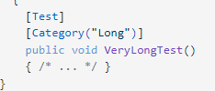

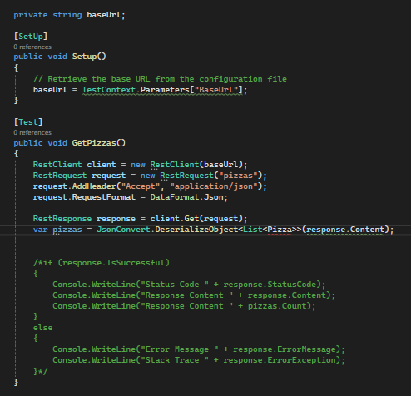

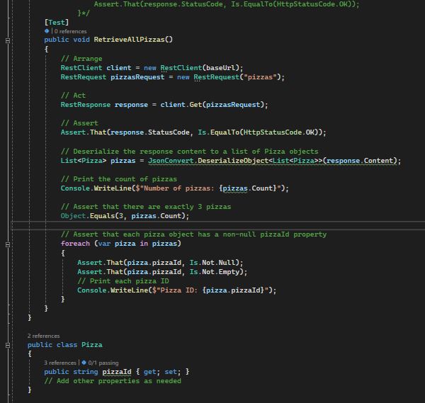
``` [Test]
public void RetrieveAllPizzas()
{
// Arrange
RestClient client = new RestClient(baseUrl);
RestRequest pizzasRequest = new RestRequest("pizzas");

// Act
RestResponse response = client.Get(pizzasRequest);

// Assert
Assert.That(response.StatusCode, Is.EqualTo(HttpStatusCode.OK));

// Deserialize the response content to a list of Pizza objects
List<Pizza> pizzas = JsonConvert.DeserializeObject<List<Pizza>>(response.Content);

// Print the count of pizzas
Console.WriteLine($"Number of pizzas: {pizzas.Count}");

// Assert that there are exactly 3 pizzas
Object.Equals(3, pizzas.Count);

// Assert that each pizza object has a non-null pizzaId property
foreach (var pizza in pizzas)
{
Assert.That(pizza.pizzaId, Is.Not.Null);
Assert.That(pizza.pizzaId, Is.Not.Empty);
// Print each pizza ID
Console.WriteLine($"Pizza ID: {pizza.pizzaId}");
}
}
}

public class Pizza
{
public string pizzaId { get; set; }
// Add other properties as needed
}

```/*[Test]
public void RetrieveAllPizzas()
{
// Arrange
RestClient client = new RestClient(baseUrl);
RestRequest request = new RestRequest("pizzas");

// Act
RestResponse response = client.Get(request);
var pizzas = JsonConvert.DeserializeObject<List<Pizza>>(response.Content);

// Assert
string responseContent = response.Content;
Console.WriteLine(responseContent);
Assert.That(response.StatusCode, Is.EqualTo(HttpStatusCode.OK), "Unexpected status code");
Assert.That(response.ContentType, Is.EqualTo("application/json"), "Unexpected content type");
Assert.That(pizzas.Count, Is.EqualTo(3), "Expected 3 Pizzas");

// Assert that each pizza has a 'pizzaId' value present
foreach (var pizza in pizzas)
{
Assert.That(pizza.pizzaId, Is.Not.EqualTo(0), $"Pizza with Id {pizza.pizzaId} is missing the 'pizzaId' value");
}*/

//WORKING ONE BELOW
/* [Test]
public void RetrieveAllPizzas()
{
// Arrange
RestClient client = new RestClient(baseUrl);
RestRequest request = new RestRequest("pizzas");

// Act
RestResponse response = client.Get(request);
var pizzas = JsonConvert.DeserializeObject<List<Pizza>>(response.Content);

// Assert
Console.WriteLine("Verifying response status code...");
Assert.That(response.StatusCode, Is.EqualTo(HttpStatusCode.OK), "Unexpected status code");

Console.WriteLine("Verifying content type...");
Assert.That(response.ContentType, Is.EqualTo("application/json"), "Unexpected content type");

Console.WriteLine("Verifying number of pizzas...");
Assert.That(pizzas.Count, Is.EqualTo(3), "Expected 3 Pizzas");

// Assert that each pizza has a 'pizzaId' value present
foreach (var pizza in pizzas)
{
Assert.That(pizza.pizzaId, Is.Not.EqualTo(0), $"Pizza with Id {pizza.pizzaId} is missing the 'pizzaId' value");
}
}*/

/* static void Main(string[] args)
{
var myBlogPost = new BlogPost("12345")
{
Title = "Title",
Body = "Body",
Author = "Author",
IsPublic = false,
PublishDate = DateTime.Now
};

var myBlogPostJson = JsonConvert.SerializeObject(myBlogPost);
}

public class BlogPost
{
public string Title { get; set; }
public string Body { get; set; }
public string Author { get; set; }
public bool IsPublic { get; set; }
public DateTime PublishDate { get; set; }
[JsonRequired]
private readonly string _id;

public BlogPost(string id)
{
_id = id;
}

}*/

/*
[Test]
public void PostPizza()
{
RestClient client = new RestClient(baseUrl);
RestRequest request = new RestRequest("pizza");

JObject payload = new JObject();
payload.Add("pizzaId", "4");
payload.Add("pizzaData", new JObject(
new JProperty("name", "Spicy Ting"),
new JProperty("vegetarian", false)
));
payload.Add("base", new JObject(
new JProperty("size", 15),
new JProperty("type", "Deep Pan"),
new JProperty("garlicSprinkles", true),
new JProperty("stuffedCrust", true)
));
payload.Add("toppings", new JArray(
new JObject(
new JProperty("name", "Beef"),
new JProperty("double", true)
),
new JObject(
new JProperty("name", "Chicken"),
new JProperty("double", true)
)
));
payload.Add("displayed", true);
payload.Add("promotion", true);

request.AddStringBody(payload.ToString(), DataFormat.Json);

//RestResponse response = client.Post(request);
RestResponse response = client.PostAsync(request).Result;
Console.WriteLine(response.Content);
RestRequest requestPizzas = new RestRequest("pizzas");
RestResponse responsePizzas = client.Get(requestPizzas);

string responseContent = responsePizzas.Content;
Console.WriteLine(responseContent);
}}}*/
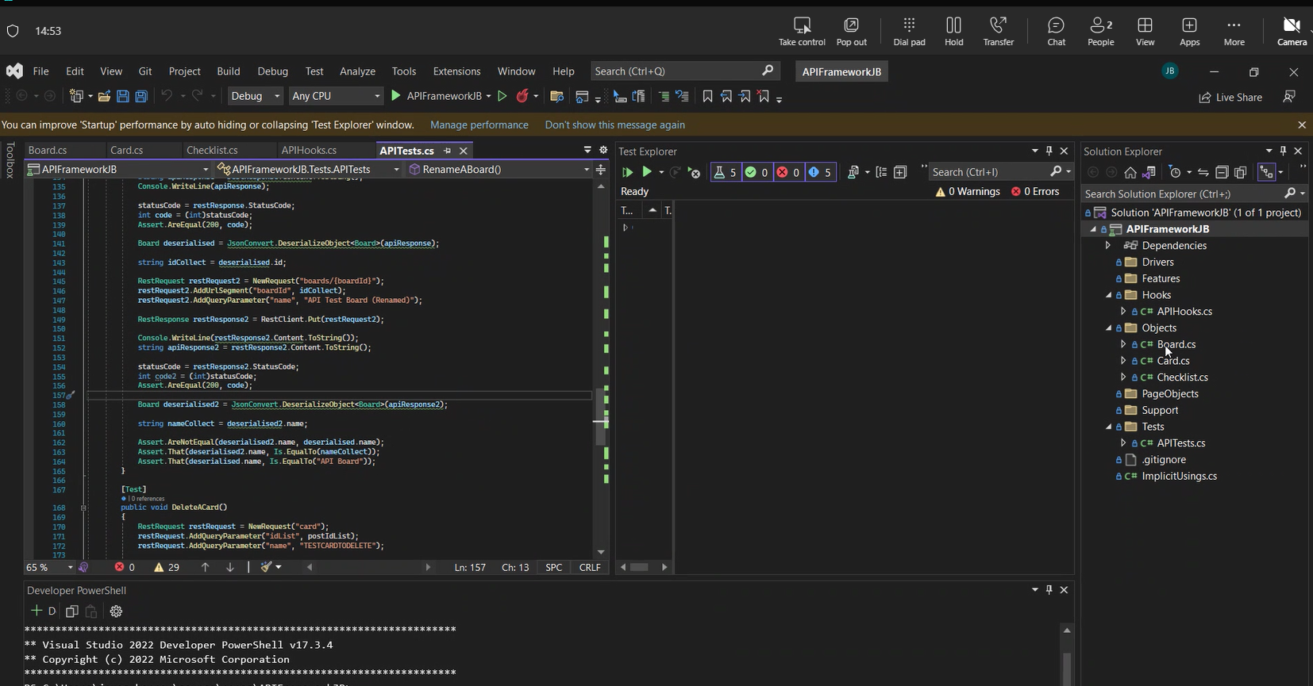
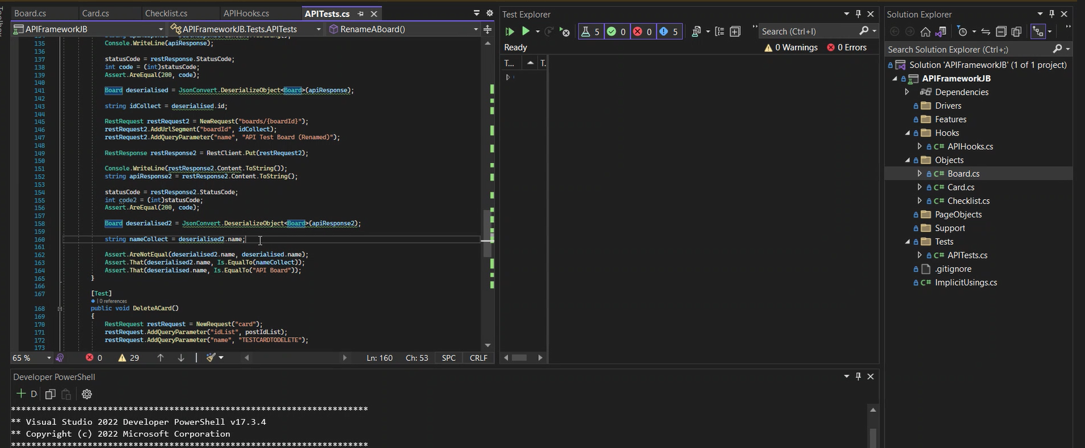
Winapp driver

